1. Flex basic

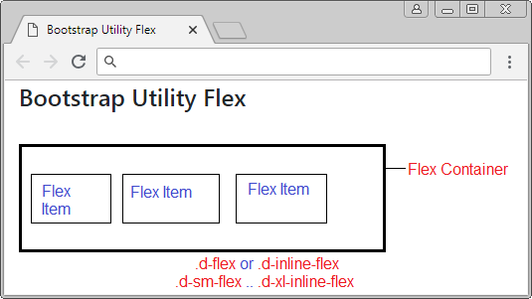

1. Flex wrap



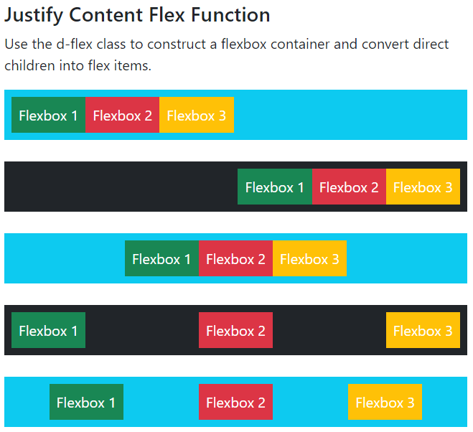



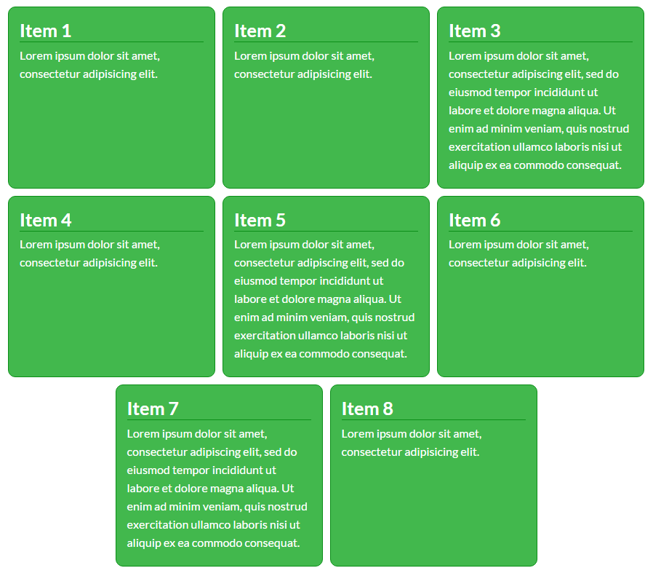

1. Assignment
3. A collage of men with their arms crossed

   Description automatically generatedA screenshot of a website

   Description automatically generated